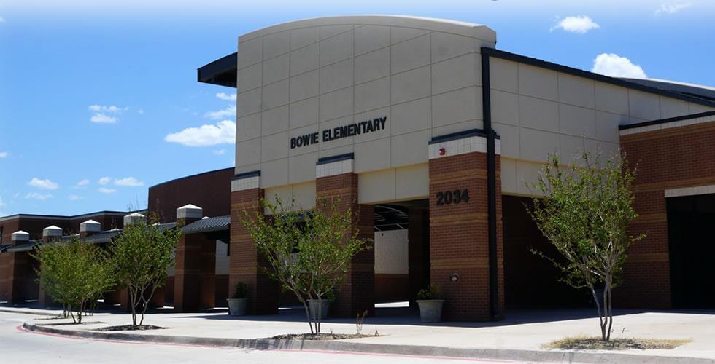  MISSION STATEMENT  At Bowie Elementary School, our mission is to educate and motivate students by meeting their individual needs in an engaging, positive learning environment. Through the joint partnership of parents, teachers, and community members we cultivate and celebrate leadership in our students and empower them to reach their full potential.  - 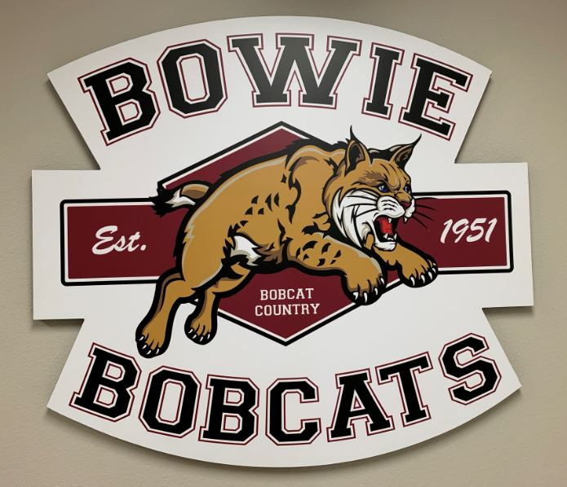 | “Leadership is communicating a person’s worth and potential so clearly that they are inspired to see it in themselves.”  -Dr. Stephen Covey  Contact Us  325-671-4770  Tina Jones, Principal  tina.jones@abileneisd.org  Clay Johnson, Assistant Principal  clay.johnson@abileneisd.org  Jessalyn Wood, Counselor  jessalyn.wood@abileneisd.org  Lisa Lester, Instructional Coordinator  lisa.lester@abileneisd.org  www.abileneisd.org/bowie-elementary  Bowie Elementary School  2034 Jeanette  Abilene TX 79602 | BOWIE ELEMENTARY SCHOOL  - Live Together  - Learn Together  - Lead Together
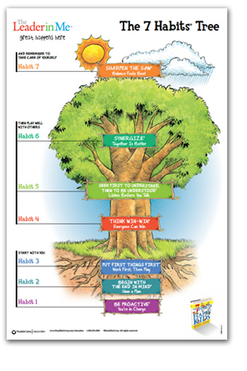  What is a Leader in Me School?  A Leader in Me school promotes the principles of the 7 Habits from Stephen Covey’s book The Leader in Me. These habits shape our school culture and priorities. | Habit 1: BE PROACTIVE – I am in charge of me.  Habit 2: BEGIN WITH THE END IN MIND – I have a plan.  Habit 3: PUT FIRST THINGS FIRST – I work, then I play.  Habit 4: THINK WIN-WIN – I win, you win, we win.  Habit 5: SEEK FIRST TO UNDERSTAND, THEN TO BE UNDERSTOOD – I listen before I speak.  Habit 6: SYNERGIZE – I am part of a team.  Habit 7: SHARPEN THE SAW – I live a balanced life.  Student artwork brightens our hallways. | What are Bowie families saying about our school?  “I love how all the teachers and staff interact with our little ones. They take the time to listen to them and get to know them.”  “Bowie has helped my family by taking the time to realize my son needed extra help when it came to reading and writing. He is doing so much better.”  “We are thankful and proud to be Bowie Bobcats.”  “This is my child’s first time in any type of schooling. I was worried about him for the first week or so, but every day he comes home telling me how good his day was. It’s great knowing he’s enjoying his first year of school!”  “The 7 Habits curriculum has been very helpful at school and home. Our whole family applies the principles and quotes them often. We are thankful and proud to be Bowie Bobcats and are forever grateful to the faculty and staff for their continued dedication to its community.”

